U.S. Consumer Product Safety Commission – Recall

Recall Date: June 17, 2020
Recall Number: 20-140

Edwards Recalls Mechanical Heat Detectors Due to Failure to Alert to Fire

Recall Summary

Name of Product: Edwards Mechanical Heat Detectors

Hazard: The recalled heat detectors can fail to activate in reaction to rising temperatures, posing a risk of failure to alert consumers to a fire.

Remedy: Replace

Consumers who use the product in life-safety applications permitted by code (for example, in elevator shafts, or in lieu of smoke detectors, manual pull stations, or sprinklers in particular settings), or in residential attics or residential garages, should immediately contact a fire or security alarm professional for free replacement and installation of the heat detector.

Consumer Contact:
Edwards Fire Safety at 800-505-5088 from 9 a.m. to 5 p.m. ET Monday to Friday, or online at
https://edwardsfiresafety.com and click on “Mechanical Heat Detector Information” for more
information, or at https://edwardsheatdetector.rsvpcomm.com.

Recall Details

Units: About 85,000

Description:
This recall involves mechanical heat detectors used indoors to detect elevated temperatures as
part of professionally installed fire detection systems for residential homes and businesses. In
residential settings, this product is installed in kitchens, attics and garages for property protection. The recalled heat detectors do not detect smoke or make an audible sound, but rather act as sensors that trigger fire alarms or security panels when elevated heat is detected. The heat detectors can be mounted to walls or ceilings and are labeled with “135F” and “NOT A LIFE SAFETY DEVICE.” The recalled units are the following:

Model # | Description | Seller
281B-PL | Heat Detector, 135F, Rate  of Rise and Fixed  Temperature | Edwards
283B-PL | Heat Detector, 135F, Fixed  Temperature | Edwards
104-13 | Heat Detector, 135F, Rate of Rise and Fixed  temperature | Interlogix
104-15 | Heat Detector, 135F, Fixed  Temperature | Interlogix
1EYC2 | Heat Detector, 135F, Rate  of Rise and Fixed  Temperature | Edwards, Grainger  P/N
1EYC4 | Heat Detector, 135F, Fixed  Temperature | Edwards, Grainger  P/N
281B-20pkg-OEM-  UTCO1 | Heat Detector, 135F, Rate  of Rise and Fixed  Temperature | Honeywell Security
281B-20pkg-OEM-  UTC20 | Heat Detector, 135F, Rate  of Rise and Fixed  Temperature | Interlogix
281B-OEM-UTC01 | Heat Detector, 135F, Rate  of Rise and Fixed  Temperature | Honeywell Security
283B-20pkg-OEM- UTC01 | Heat Detector, 135F, Fixed  Temperature | Honeywell Security
73340U | Heat Detector, 135F, Fixed  Temperature and Rate of  Rise | Mirtone
73342U | Heat Detector, 135F, Fixed  Temperature | Mirtone
AI281B | Heat Detector, 135F, Fixed  Temperature and Rate of  Rise | Edwards
AI283B | Heat Detector, 135F, Fixed  Temperature | Edwards
281A | Heat Detector, 135F, Fixed  Temperature and Rate of  Rise | Edwards

Incidents/Injuries: None reported

Sold At: Edwards’ distributors, electrical wholesalers, contractors, and fire safety professionals nationwide from January 1979 through May 2018 for between $6 to $7 per unit.

Importer: Edwards Fire Safety, of Bradenton, Florida

Manufactured in: China

Photos

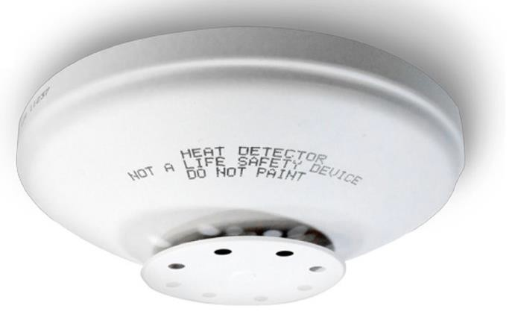
Recalled Edwards 280 Series Mechanical Heat Detector

Footer
About the U.S. CPSC
The U.S. Consumer Product Safety Commission (CPSC) is charged with protecting the public
from unreasonable risks of injury or death associated with the use of thousands of types of consumer products. Deaths, injuries, and property damage from consumer product incidents cost the nation more than $1 trillion annually. CPSC’s work to ensure the safety of consumer
products has contributed to a decline in the rate of deaths and injuries associated with consumer
products over the past 40 years.

Federal law bars any person from selling products subject to a publicly announced voluntary recall by a manufacturer or a mandatory recall ordered by the Commission.

For lifesaving information:
- Visit CPSC.gov.
- Sign up to receive our e-mail alerts.
- Follow us on Facebook, Instagram @USCPSC and Twitter @USCPSC.
- Report a dangerous product or a product-related injury on www.SaferProducts.gov.
- Call CPSC’s Hotline at 800-638-2772 (TTY 301-595-7054).
- Contact a media specialist.

